Session 6
Task 1
Create a SQL query using GROUP BY to show the total number of orders placed by each user in an 'orders' table, displaying user_id and order_count.
Query
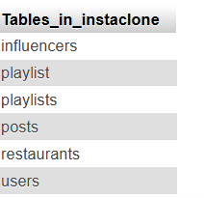
TASK 2
Write a SQL query to display the names of restaurants from a 'restaurants' table that have received an average rating above 4.0, using GROUP BY and HAVING.
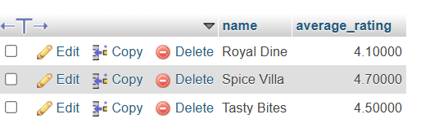
TASK 3
Suppose you have a 'payments' table with columns user_id, amount, and payment_date. Write a subquery to find user_ids who have made a single payment above ₹2000 in any transaction.
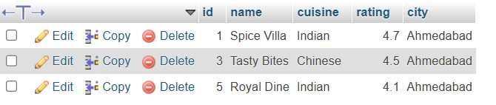
Task 4
Using a nested subquery, display the names of movies from a 'movies' table that have a higher average rating than the overall average rating of all movies.<br><br><em><strong>Hint:</strong> Use a subquery to calculate the overall average rating, then compare each movie's average rating against it in the main query.</em>


